**CSE 3330-004 PROJECT 1**

**Team number: 14**

**Team members: Araohat Kokate, Athrva Arora, Inshaad Merchant**

**Date: 10/06/2023**

1. **Tools used in the Project –**

* Lucid Charts – Used for creating ER diagrams.
* SQLlite3 – Used for database creation and querying
* Command Prompt – Used for accessing and running SQL queries.
* VS Code – Used for writing and editing SQL queries.

1. **ER Diagram –**

Assumptions made while creating the ER Diagram are –

* The total number of tickets that can be booked in each category (Premium and General ) is 10.
* Number of tickets in waiting list is 2.
* Total number of trains are 5.
* Only two categories of Tickets are available: Premium and General Ticket.
* Any number of stops made by a train before its destination and their bookings are not considered.
* Not every passenger is going to be able to book tickets on a given day (If they are waitlisted). Hence not all passengers participate in “Books” relationship.
* All the passengers have an SSN, which is its primary key, Hence Passenger is a strong entity.
* All trains have a Train status. One train can have different train statuses given that it has different Available weekdays.
* All the trains have atleast one Source station and destination station.
* All passengers can book multiple trains.

**Readme:**

Steps for creating the database form the given dataset and SQL files are as follows:

* Type “**sqlite3 <<DB_Name>>**“ in Terminal – Creates a new database file using sqlite3
* **.read createTables.sql** – Reads the createTables.sql file to create the tables.
* **.read importData.sql** - Reads the importData.sql file to load the data from csv files into the respective tables.
* **.read selectQueries.sql** – Reads all the queries in selectQueries.sql

1. **Source Code of SQL CREATE statements:**

In the file named “createTables.sql” you will find the create statements.

*Commands to use:* .read createTables.sql

*To verify :* .schema

Below is the screenshot of how file “createTables.sql” was used to create the tables for the given database. Command “.schema” is used to verify that the tables have been created.

1. **Method used to load the data into the tables :**

Import Statements are listed in “importData.sql” .

*Command to use:* .read importData.sql

The Command “ .read importData.sql” reads the file “ importData.sql” and imports all the .csv files of the given dataset into its respective tables in the database.

The csv files provided were modified such that the headers (in the first line of each csv file) were removed.

Also, file “Train.csv” was modified such that the multivalued attribute “Available_on_Weekdays” was split down to create new row for each possible values of the attribute.

We also in the file “Passenger-1.csv” we changed the dates by removing the slashes(/) and replaced them with Dash(-) so that we can import it as a date datatype.

1. **Source code for the SQL SELECT statements and Query Results:**

In the file named “selectQueries.sql” you will find all the select statements listed below.

1. Given a passenger’s last name and first name and retrieve all trains they are booked on.

*Command to use:* .read query2.sql

**Source Code:**

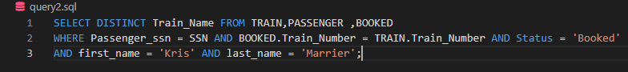

**Output:**

1. Given a day list the passengers traveling on that day with confirmed tickets.

*Command to use:* .read query3.sql

**Source Code:**



**Output:**

1. Display the train information (Train Number, Train Name, Source and Destination) and passenger information (Name, Address, Category, ticket status) of passengers who are between the ages of 50 to 60.

*Command to use:* .read query4.sql

**Source Code:**



**Output:**



1. List train name, day and number of passengers on that train.

*Command to use:* .read query5.sql

**Source Code:**

**Output:**

1. Enter the train name and retrieve all the passengers with confirmed status traveling on that train.

*Command to use:* .read query6.sql

**Source Code:**



**Output:**

1. List passengers that are waitlisted including the name of the train.

*Command to use:* .read query7.sql

**Source Code:**

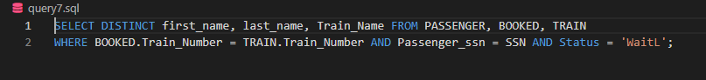

**Output:**

1. List passenger names in descending order that have '605' phone area code.

*Command to use:* .read query8.sql

**Source Code:**

**Output:**

1. List name of passengers that are traveling on Thursdays in ascending order.

*Command to use:* .read query9.sql

**Source Code:**



**Output:**



1. **Contributions:**

ER Diagram – All of us worked together on ER Diagram.

importData.sql – Athrva Arora

createTables.sql – All of us worked together on ER Diagram.

query2.sql – Athrva Arora & Araohat Kokate

query3.sql – Athrva Arora & Araohat Kokate

query4.sql - All of us worked together

query5.sql – Athrva Arora & Inshaad Merchant

query6.sql – Athrva Arora & Inshaad Merchant

query7.sql – Inshaad Merchant & Araohat Kokate

query8.sql - Inshaad Merchant & Araohat Kokate

query9.sql - Inshaad Merchant & Araohat Kokate

Project Report – Athrva Arora

1. **HONOR CODE:**

I pledge, on my honor, to uphold UT Arlington's tradition of academic integrity, a tradition that values hard work and honest effort in the pursuit of academic excellence.

I promise that I will submit only work that I personally create or that I contribute to group collaborations, and I will appropriately reference any work from other sources. I will follow the highest standards of integrity and uphold the spirit of the Honor Code.

Student name: Araohat Kokate Student ID: 1001829841

Student name: Inshaad Merchant Student ID: 1001861293

Student name: Athrva Arora Student ID: 1001935988